Test 4 2019 Past Questions

Resource Free

Question 1 [2 marks]

Determine n (the number of Bernoulli trials) and p (the probability of success) if a binomial distribution has an expected value of 32 and a standard deviation of 4.

Question 6 [2 marks]

Discrete probability distributions can be classified as Binomial and non-Binomial. List the most important assumptions you need to make to be able to use Binomial distributions in a real-life situation.

Resource-Allowed Section

Question 7 [6 marks: 1, 1, 2, 2]

The discrete random variable X has the following probability distribution.

x | 1 | 2 | 3 | 4 | 5
P(X = x) | 0.1 | 0.15 | 0.3 | 0.25 | 0.2

(a) Determine the expected value E(X).

(b) Determine the variance Var(X) to two decimal places.

(c) State the value of Var(-2X + 3)

(d) Determine 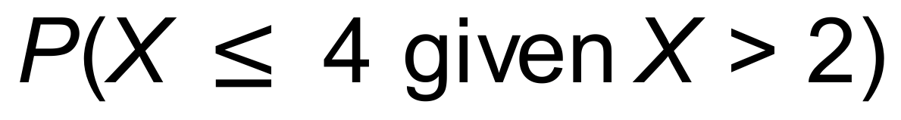.

Question 8 [2 marks]

Daniel has been offered a sales position at a car yard. His weekly pay will comprise two components, a retainer of $300 and a commission of $500 for each new car sold. The following table shows the probability of his selling specific numbers of cars each week.

x | 0 | 1 | 2 | 3 | 4
P(X = x) | 0.3 | 0.4 | 0.25 | 0.04 | 0.01

Calculate Daniel’s expected weekly pay.

Question 11 [3 marks]

Let us suppose that each time a particular basketball player shoots a three point attempt the probability of scoring is 0.35. How many three point attempts does this player need to make for the probability of at least two successes to exceed 0.6?

